ENVIRONMENTALISM

Environmentalism is a movement that aims to protect the natural world and its resources. It’s about taking care of the world we live in. Additionally, it means trying to keep our air and water clean, protecting animals and plants and using resources in a way that doesn't harm the environment. It's important to take care of the environment so that we can continue to live healthy lives, and so that future generations can too. This includes things like recycling, saving energy, and supporting efforts to protect nature.

Greenhouse effect
When the sunlight reaches the Earth's atmosphere, some reflected heat escapes and some is trapped by greenhouse gases and further increases the Earth’s temperature. The Greenhouse gases include water vapor, carbon dioxide and methane. Human activities such as burning fossil fuels, deforestation, and industrial processes are the primary sources of greenhouse gas emissions.
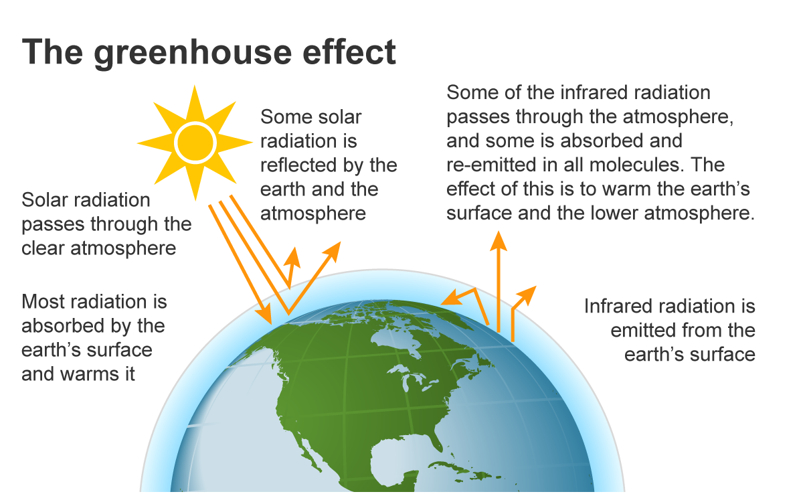

How to reduce greenhouse gas emissions
- People must drive less, reduce their meat and milk consumption or save electricity.
- Using renewable energy sources such as solar, wind, hydroelectric, and geothermal can reduce greenhouse gas emissions by reducing our reliance on fossil fuels.
- If people would produce and use more alternative energy sources, for example when they would install a solar panel on the roof of their house, greenhouse gas emissions could be reduced.
- The clearing of the rainforests also must be stopped in order to reduce carbon dioxide.
- Using public transportation or carpooling reduces cars on the road, lowering greenhouse gas emissions.
Global warming/ Climate change
Global Warming is the increase of Earth's average surface temperature due to effect of greenhouse gases. Generally, the global warming is caused by the greenhouse effect. It is important to mention that the warming effect has been speeding up lately. The reasons for this are the gases spewed out by cars, planes, factories and power stations and the clearing of rainforests. That is why emissions must be reduced by finding alternatives to fuel and promoting environmentally friendly production.
Possible effects of global warming:
- More extreme weather: Global warming can cause more frequent and severe heat waves, storms, floods, and droughts, which can damage homes, crops, and infrastructure.
- Economic impacts: Climate change can harm industries such as agriculture, tourism, and fishing, leading to job losses and economic instability.
- Rising sea levels: As the Earth's temperature rises, glaciers and ice sheets melt, causing sea levels to rise. This can lead to flooding and the loss of coastal habitats.

That means that there are extreme weather events more and more often. These weather events make the risks worse we see today: For example, hurricanes are stronger, bigger, and slower and floods are more often than before. In conclusion, global warming is a complex and pressing issue that is affecting the Earth's climate, ecosystems, and societies.

Environmental threats
The environment around us is facing many challenges that are affecting our planet and the living things that call it home. Some of the biggest threats include:

- Climate change: Heat waves, droughts, flooding, storms, decrease in crop yields, and rising sea levels are just some of the effects we’re seeing from climate change. This happens when too many gases are released into the air, making it hotter and changing the weather in dangerous ways.

- Pollution: It is caused by the release of harmful substances into the air, water, and soil, and has a range of impacts on human health, wildlife, and ecosystems. Today, water shortage and polluted water are posing a big threat to the human existence across many nations of the world.

- Deforestation: This is when forests are cut down, taking away homes for animals and making the air less clean. When trees are cut down, the carbon dioxide they have stored is released into the atmosphere.

- Overfishing: Too many fish are caught, which leads to less fish and harming the animals that depend on them. Because of irresponsible fishing, many species of fish are on the brink of extinction. And as we’ve already covered, a loss in biodiversity means trouble for us all.

- Loss of biodiversity: Many plants and animals are in danger of extinction due to overfishing, deforestation, habitat destruction, pollution, and other factors. This can have a serious impact on the ecosystem and, in turn, affect humans as well. It is important to take action to protect biodiversity and preserve the environment for the benefit of all species.

- Overpopulation: The growth of the human population is causing increasing pressure on the environment and loss of resources. The food problem is just one of many problems resulting from this growth.

It is essential that we continue to work together to address environmental threats, to protect our planet, and to support the well-being of all its inhabitants. Only by taking collective action, we can ensure a sustainable future for ourselves and for generations to come. Everyone can help to protect the environment by doing things like recycling, saving energy, and supporting efforts to protect nature.

